**Object oriented programming**

**Assignment**

**Natiqa Batool**

**BCS211141**

**Submitted to: Sir Syed Abdul Basit**

#include <iostream>

using namespace std;

class dist

{

private:

int feet;

int inches;

public:

dist()

{

feet = 0;

inches = 0;

}

dist(int f, int i)

{

feet = f;

inches = i;

}

void input()

{

cout << "Enter feet: " << endl;

cin >> feet;

cout << "Enter inches: " << endl;

cin >> inches;

}

void display()

{

cout << feet << "\' " << inches << "\"" << endl;

}

void add(dist d1, dist d2)

{

feet = d1.feet + d2.feet;

inches = d1.inches + d2.inches;

feet = feet + (inches / 12);

inches = inches % 12;

}

dist operator%(const dist& d1)

{

dist d;

d.feet = d1.feet + this->feet;

d.inches = d1.inches + this->inches;

d.feet = d.feet + (d.inches / 12);

d.inches = d.inches % 12;

return d;

}

};

int main()

{

dist d1;

dist d2;

dist d3;

cout << "before assignment operator" << endl;

d1.input();

cout << "Distance 1 : ";

d1.display();

cout << " " << endl;

cout << "Distance 2 : ";

d2.display();

cout << "" << endl;

cout << "after assignment operator" << endl;

d3 = d1 % d2;

cout << "Addition of distance 1 and 2 : ";

d3.display();

return 0;

}

**Screenshot:**

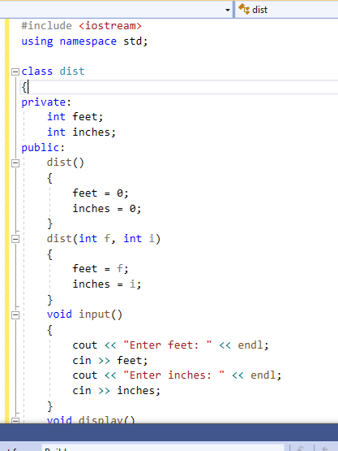

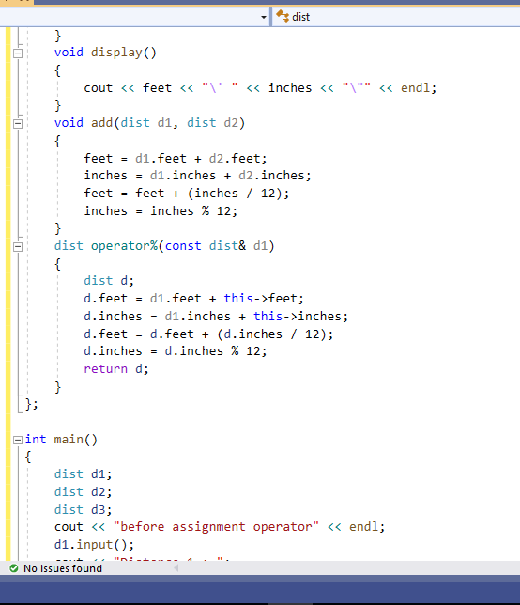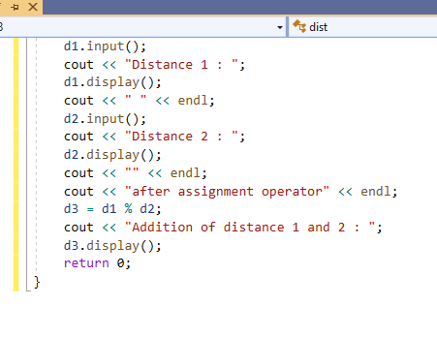

**Output:**

